**Incremental Intelligence**

**Author Name1, Author Name2 and Author Name1,2**

1 Department One, Institution One, City One, Country One

2 Department Two, Institution Two, City Two, Country Two

E-mail: xxx@xxx.xx

Received xxxxxx

Accepted for publication xxxxxx

Published xxxxxx

**Abstract**

Intelligence enables system to achieve goals in a given environment. Goal defined by user limits the ability achieve Intelligence bound by dataset and associated algorithms. Goal is characterised by set of favourable outcomes. Goal translates to recursive subgoals to atomic tasks and outcomes. Goal as a function maximises favourable outcomes and minimises unfavourable ones.

Intelligent systems use knowledge and corresponding stimulus-response to traverse the path towards

achieve system goals associated to the system and host environment.

, true intelligence is achieved when the goals refer to the goal of the system. Larger the goal, proportionally the

requires the A system design to deliver intelligence by human, is constrained to deliver Intelligence limited to achieve the goal defined by human. To achieve true intelligence the system, require to be built to achieve the goals set forth by the system. This transfer of ownership is a challenge and limiting factor of current AI.

goal by the experience embedded in the Dataset and algorithms of the key challenges to building Intelligent System is the clarity in defining Intelligence itself. The clearer the requirement the simpler the complexity. Intelligence delivered by CNS central nervous system could be a reference to build on. Medical, Clinical and pharmacology provide wealth of untapped insight to build intelligent systems that demonstrate cognition, heavily energy optimized.

Current AI & ML systems depend on 2 major components, Algorithms and Dataset. Dataset does not evolve with the host environment and algorithms are predominantly applying combinatorial logic. To deliver a feature as complex as intelligence applying trained model is far-fetched.

Fitness for adoption of AI as a Technology would require a system that supports

1. Meaningful response to start in near Real-time. Unlike Regression, classification responding on completion of Application execution
2. Evolve incrementally, delivering Intelligent responses converging to Rewarding Outcome
3. Containing the problem space with magnification of the solution space
4. Spread the entropy of the system over interval and conserving energy and infrastructure utilization

This approach allows the system to produce insightful response initially to a evolved response incrementally applying Intelligence.

Keywords: Intelligence, Incremental, Evolve

* **Need for Incremental Intelligence**

Adoption of new technology would require attaining maturity, product, services, support and most importantly business case. With no exception AI would require to stand the test to sustain and evolve. The position of AI being highest in the technology stack, combined with the requirement to deliver executive functions on the lines of predication, Diagnosis, autonomic capability. Each of the requirements comes with responsibility, dependence, societal and ethical importance.

Algorithms, mathematical techniques, Data processing functions, ensemble of methods, provides insight into the problem space and provide response based on trained models, and produce learned outcomes. The solution requires customization, and designed for specific requirement. In a manner most of the AI solutions are Design support system. Predominantly AI solutions enable consulting firms to provide advice.

As a product AI would require the following requirements to be fulfilled.

* Off the shelf product with custom installation and deployment.
* Dependable Intelligence, protect interest of human life, environment.
* Produce outcomes with Error not more thanhumancould have performing the same task.
* Provide systemic response with initial response and evolved response as intelligence is generated

# Drawing parallel from the biological world, human intellectprovide first response to stimulus and refine based on further stimulus, feedback and learned experience. A system with the above principle would have ability to incrementally deliver intelligent response. A design to deliver both high accuracy and degree of complexity has high probability of falling short of expectations. Hans Selye (1907–1982) hypothesised three phases of human response, alarm reaction, resistance, and exhaustion; this is finding relevance associating stress and diseases.

Dimensionalreduction, feature selection, embeddingdimensions, are methods to achieve efficiency and manage resource utilization, reduce the ability to exploit the knowledge content in the dataset, potential of the algorithm and computational resources. A system design to explore the environment, stimulus, features of the dataset, instead of feature engineering, move to incremental feature extraction would magnification of the scope of the region of interest and deliver intelligence with limited resources.

* **Technology Evolution**

Technology evolution has been driven by preceding technology. Consider evolution of technology,

1. Structural Engineering and material science, Civil engineering
2. Simple machines to Industrial resolution
3. Electro-magnetic to power generation, signals, communication, Electrical engineering
4. Semiconductor enabled build devices dense functions, mixed signal and Computation
5. Widen the scope of computing, using Organic nano structures, structures to functions. From away from bitwise to object, function, Goal based design. New materials and methods in true sense hold the key to next generation technology. Move from Neuromeric computing to Neu functional computing.
6. **Silicon to Biological Intelligence**

Analog circuits enable signal processing, rectification, filtering, amplifying, attenuating, modulating, transmission, display and many more, applying the above principles enabled functions such as communication, sensing, motion, detection, actuation, controlling.Digital Circuits enabled creation and applying logical arguments, application, realize and exploit mathematical methods. The fact remains, the laws of physics, chemistry remains intact, Online Payment Transaction to movement of Electromagnetic Energy. It sounds ironical the third important branch of science did not find a place. Perhaps, it’s time to consider selected knowledge elements from Natural Intelligence the Brain.

Factors with high relevance in the biological system that could assets to generate Intelligence,

* 1. Basics of chemistry such as, Periodic Table, reaction, products chemical states, chemical equilibrium, acid & base, oxidation & reduction reactions, chemical kinetics,nomenclature and chemical bonding continue to be reverentAs information is generated, transferred, processed and responds via cascade reaction. Energy cycle is expressed as chemical haemostatic process.
  2. Basics of electricity such as laws of Electric charge, EMF, potential difference, ion flow, controlling, modulating the flow of charges continue to be relevant, supporting the functions as Membrane Tranconductance, ion gated channels, protein structure folding

Realm of Digital and binary logic would require revalidation and readjusted as required.

Though logical functions and decisions are well known from cognitive perspective, there is no known evidence of pure binary bit operations, functions in the human brain. Logic exists in the form of threshold cross over detection and corresponding operation.

Natural Neuron cell and Artificial Neuron, could be considered for comparison. One of the intriguingfacts of biological intelligence is realized with only of one type of cell, Neurons and few variants.

Perceptron, Modelled Neuron and Biological Neuron though modelled as similar functions. however, the complexity of biological neuron is unprecedented. Each Neuron perform dual function

1. Processing Element
2. Networking Element

Current trend to use Neural Nets applying Deep Learning algorithmscontinue to inherit computational and energy constrain.

Every neuron carries DNA structures that characterize the system and the process of Transcription via mRNA modulates the response specific stimulus. As each neuron has the ability to modify the response. This makes the system multi-processing.

Every neuron represents a communication link as part of the central nervous system. The exchange of neurotransmitter at the synaptic junction has the ability to transform the signal.

Given the number of neurons, the scale of processing capability incrementally as the stimulus traverse functional area of the nervous system and brain, converging to generate outcomes, sub-outcomes and diverge when options are presented. The system presents intelligent outcomes as stimulus is presented and outcomes generated with merits.

1. **Design for Incremental Intelligence**

Considering methods to design and analysis of systems. Infinite impulse response and Finite Impulse response are proven methods.

Infinite impulse response, applied to Intelligent systems enable response to stimulus incrementally as the stimulus is analysed.

Finite impulse response, applied to Intelligent system enable convolution of stimulus and hypothesis. A feature that supports learning patterns.

Generation of Intelligence would require exploiting known methods, this would require exploration in new light. Consider the following

* Eigenvalue could represent the magnification of the hypothesis in the direction towards the system Goals. Magnification of the problem space enable objectively focus utilisation the same resources
* Magnification of the problem space in steps would expose the hidden dimensions and information content in the data, that enables the system to orient to solution with higher relevance.
* Information Entropy, as the inputs arrive the entropy of the systems could be modelled as Gaussian. Initially the entropy increases with episodes of experience, with time the system ingests, assimilates, realise features, structures to data frames, consolidate the stimulus and use the model, constrains and produce responses. Neural imaging exhibits intense spiking activity, reduce with time.

1. **Paradigm shift**

Computing Platforms are designed to perform tasks instructed by the user. The requirement, process and outcome are user centric. In order to deliver natural intelligence function the requirement, process and outcome needs to be transferred to the platform.

There is convincing evidence to such architecture. The RMSSD (root mean square of successive differences between normal heartbeats) **RMSSD** represents the rate of blood flow and oxygen levels, energy transfer. RMSSD value are higher in the region of executive functions of the brain, in the Autonomous & Parasympathetic mode.

The implication of the above finding opens up architecture and options to explore and exploit.

In brief the application shifts to execution state while in standard wait cycle.

While(!kbhit()) {

}

Linux uses /sys/devices/system/cpu/cpuidle/ in sysfs.

Conventional operating systems are designed to switch the system to power down mode proportionally to the usage. This is in contrast to natural intelligence behaviour. This trivia needs to be understood and applied to advantage.

**Realising Natural Intelligence**

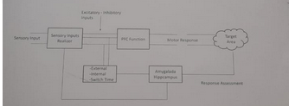

Consider the architecture presented in the figure. Hybrid system, integrating conventional AI and Control system.

There exist 2 paths.

1. The forward path, the system responds to stimulus presented based on the Transfer Faction in the form of algorithm, Model.
2. The feedback path represents the autonomous mode. Relatively idle when the system is engaged in responding to stimulus. During the absence of activity, the autonomous system, engages in Re-processing the episodes, the rewarding experience.
3. The Autonomous mode components emulate inputs that could **Convert** rewarding experience to higher degree and **Invert** negative rewarding experience to rewarding ones. Stimulus from multiple sources universalized allows the Autonomous systems perform multimode operations
4. The above model allows the system to be power conservative. The energy requirement for Physical requirement is approximately equal to resting requirement.
5. The stimulus regenerated is synthesized by the system in heuristic manner. Though the stimulus is simulated the Transfer Function considers them as actual and provides response.

1. The system allow to assimilate the stimulus, response, complemented with iterative hypothetical exploration of the problem space allow the system to evolve and deliver intelligence in an incremental manner.
2. Basic concept of Control system would require stability to be established. In natural system, the haemostasis cycle is considered the central goal of the system. In proposed intelligent system, interestingly, the thermal heat generated by the system could be used to assess the system stability.

**Visual Complex Use case**

Vision complex is an area that consumes relatively significant energy, complex by design and prominence enabling evolved behaviour of human. Human rely on Vision for spectrum of abilities from existence to social skills, aesthetic experience to name a few.

The following section investigates the merit and relevance of Incremental learning in vision processing.

To begin from the biological system, the vision complex is part of the occipital lobe and consists of 4 regions with exclusive functions. Physiologically areas labelled 17, 18 & 19 consolidate the vision function

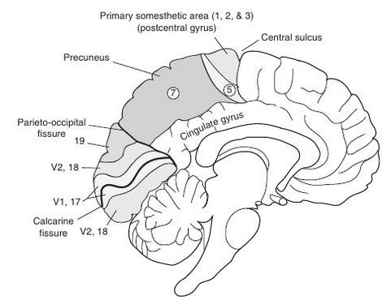

The challenge working with biological system is the system has evolved incrementally addressing requirements matching the nature and challenges they pose.

Simplfied functional view of human visual complex is presented below

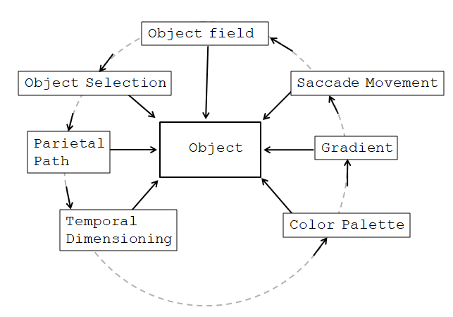

The flow of processing pipeline is modelled as follows steps

|  |  |  |
| --- | --- | --- |
| **Function** | **Action** | **Intelligence** |
| Object in Visual Field | Ca+ Na+ Polarisation Cyclic GMP-gated channels activation | Attention to Presence of Object |
| Parietal Path Tracking | Activating the recti muscles part of the ocular motor systems. Traces the path of the object | Pre-cursory Right-angle hint Square like object |
| Temporal dimensioning | Estimation based on occularmotion and embedded angular features | Square transforms to rectangle |
| Colour determination | Addition of colour palette, distribution | Colour≈ Browne  Smell ≈ Baked  Rectangle ≈Cake? |
| Contour, Gradient interpretation | Binocular disparity, feature correlation | Shape refined to Cube. surface perforated |
| Saccade feedback and control | Iterative Executive function driven control loop | Emotion response, share ,occasion |

Theoretical explanation

* 1. Object is presented in the visual field. The energy in the photons results in polarisation Ca+ and Na channels and in turn cause activation of the Cyclic GMP-gated channels
  2. Assuming the object presented is a rectangle to manage the simplicity
  3. Object fixation could be attributed to executive function, object that is relevant to the episode and goal
  4. The parietal function engages on the objects, could be named as ‘in pursuit’. Activating the recti muscles part of the ocular motor systems. As the path integrates into the motor system, association to higher order visual function is implicit.
  5. The parietal function traces the object and provides an estimated output, ‘could be a square’
  6. The temporal system based on system timer determines the dimensions. To decide ‘it’s a rectangle’
  7. The ocular dominance column determines the features of the object in pursuit, colour, occluded contours, gradients
  8. As the details are being supplied to the executive functions, the system based on the ‘train of thought’ drives the visual complex to generate dataset of relavence

**Conclusion**

There is an inherent advantage delivery of Intelligence incrementally.

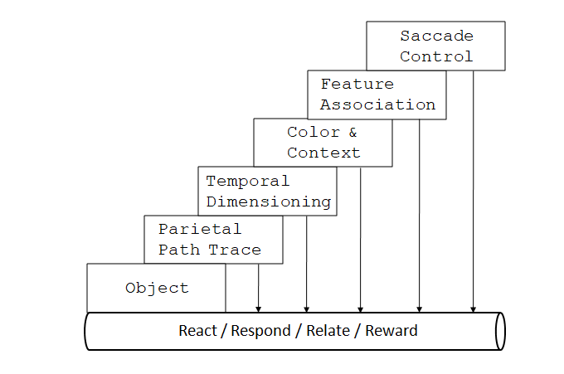

* Compared to Regular AI methods Incremental model of delivering intelligence optimises Resource
* Incremental Intelligence model enables AI systems to initiate responses not waiting for the Algorithm execution and dataset, instead raise the Intelligence in the response.
* Incremental intelligence allow systems to take corrective actions as early stage response are presented
* Incremental Intelligence model explores dimensions of the problem space independently this brings in the diversity in response which the algorithmic model lacks
* Incremental Intelligence model, is close to human intelligence providing responses in stages with higher degree of relevance.
* Enable system to exhibit cognitive function.

1. **Discussion**

Incremental Intelligence is a concept extracted from medical science. Broadman’s classification was used as reference.

**References**

1. Surname A, Surname B and Surname C 2015 *Journal Name***37** 074203
2. Surname A and Surname B 2009 *Journal Name***23** 544